Hands-On Lab
Lab Manual
Develop Windows Application to read audio file with library Libsndfile

Contents
Develop Windows Application to read audio file with library Libsndfile i
Lab Objective 3
Exercise 1 – Prepare the library Libsndfile 3
Task 1 – Download and install the library Libsndfile 3
Task 2 – Look over the document of Libsndfile 4
Exercise 2 – Create Windows Application MFC 4
Task 1 – Create application 4
Task 2 – Configure the project to use library Libsndfile 9
Exercise 3 – Write code to read audio file and output to text file 13
Task 1 – Generate source to process event of buttons 13
Task 2 – Call the library Libsndfile 15
Exercise 4 – Analysis code 20
Task 1 – Run Code Analysis on solution 20

Estimated time to complete this lab: 45 minutes

Lab Objective
The objective of this lab is to introduce you how to develop a Windows Application to use library Libsndfile (http://www.mega-nerd.com/libsndfile).
- Download and setup Libsndfile on Windows.
- Use Libsndfile for Windows Application MFC
  - Open file audio such as WAV
  - Read frame of each channel
  - Write each frame of each channel into a text file
(Refer source code from https://github.com/erikd/libsndfile/blob/master/examples/sndfile-to-text.c)

Note:
- I have been installed the Libsndfile Win32 on Window 7 64 Bit. So the home directory of Libsndfile is “C:\Program Files (x86)\Mega-Nerd\libsndfile”
Prerequisite:
- Visual Studio 2012 or later

Exercise 1 – Prepare the library Libsndfile

In this exercise you will download and install the binary package of Libsndfile for Windows.

Task 1 – Download and install the library Libsndfile
  - Download Libsndfile.
Download the latest version of Libsndfile Win32 installer at “http://www.mega-nerd.com/libsndfile/#Download”. At this time of writing of this text, the latest version of Libsndfile is 1.0.25 ( http://www.mega-nerd.com/libsndfile/files/libsndfile-1.0.25-w32-setup.exe)

  - Execute the installer.
For Windows 7 64bit, the default home directory of Libsndfile Win32 is “C:\Program Files (x86)\Mega-Nerd\libsndfile”.
For Windows 7 32bit, it is “C:\Program Files\Mega-Nerd\libsndfile”.
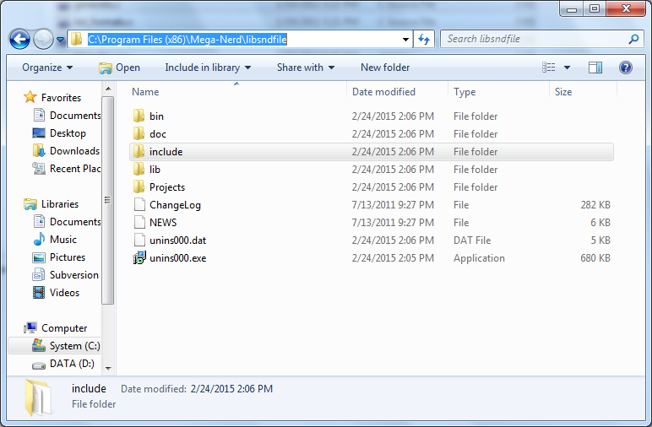

Task 2 – Look over the document of Libsndfile
Browse the folder “C:\Program Files (x86)\Mega-Nerd\libsndfile\doc”. Look over the Program Interfaces at “C:\Program Files (x86)\Mega-Nerd\libsndfile\doc\api.html”
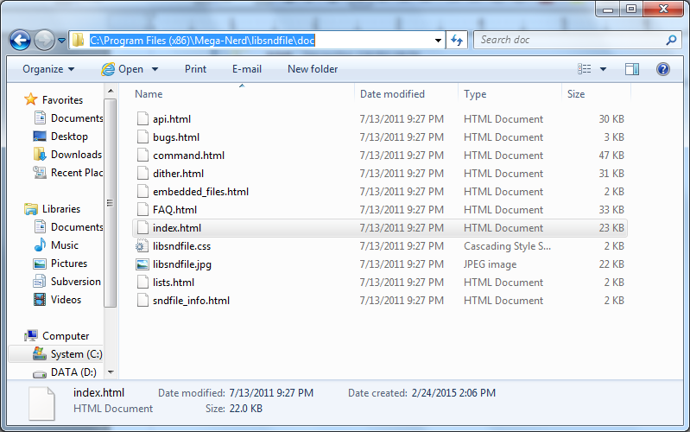

Exercise 2 – Create Windows Application MFC

Task 1 – Create application
  - Start Visual Studio.
Create a MFC Project with following information:
Name: AudioChannelFrame
Location: <Define yourself>
Solution name: AudioAnalyzer
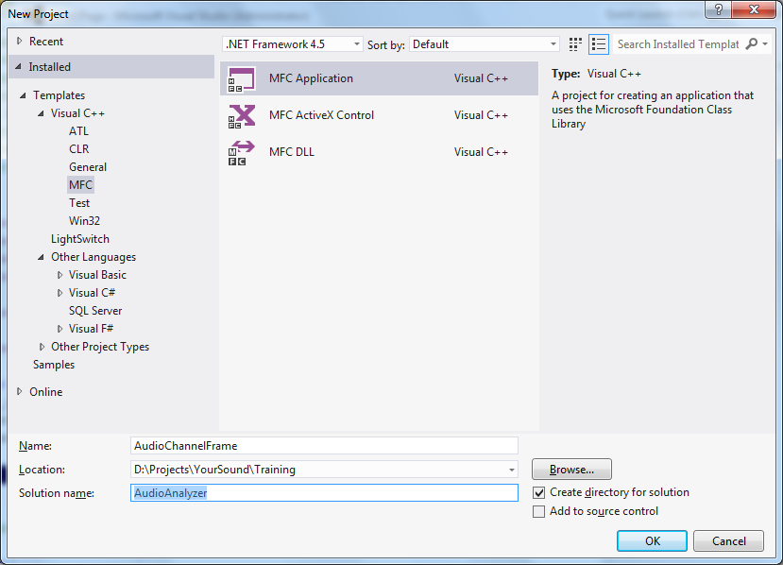
Select Application Type: Dialog based
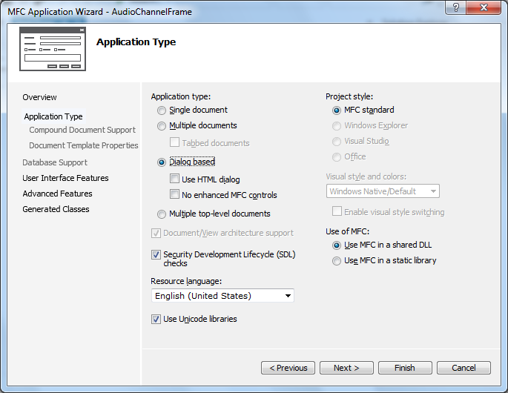

Click on “Next” button to continue. Then click on “Finish” button.
The default layout of application is as below:
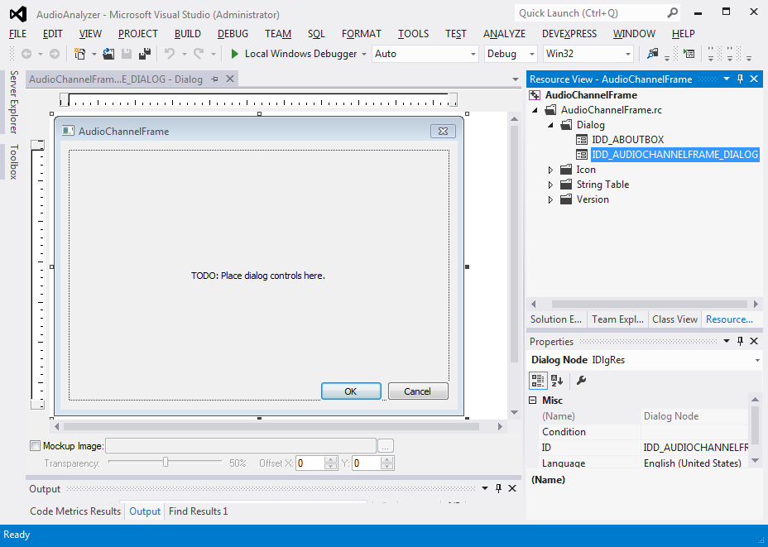
  - Create layout for the application.

Define ID for screen items as following:
Screen item | Type | ID | Note
Input file: | Static text | IDC_LAB_INPUT_FILE
Text box for input file | Edit Control | IDC_EDT_INPUT_FILE | Bind to variable “m_editInFilePath”
Browse | Button | IDC_BTN_BROWSE
Output file: | Static text | IDC_LAB_OUTPUT_FILE | Bind to variable “m_editOutFilePath”
Text box for output file | Edit Control | IDC_EDT_OUTPUT_FILE
Analyze | Button | IDC_BTN_ANALYZE
Log | Static text | IDC_LAB_LOG
Text box for result log | Edit Control | IDC_EDT_RESULT | Read-only. Bind to variable “m_editLogResult”
Cancel | Button | IDCANCEL

- To change default ID of screen items: right-click on the item, select menu item “Properties” to display Properties of the items. Then change value of ID.

- To bind variable to edit control: right-click on the edit control, select menu item “Add Variable...”

Input value for “Variable name”.

Similarly, binding variable for item “Text box for output file”:
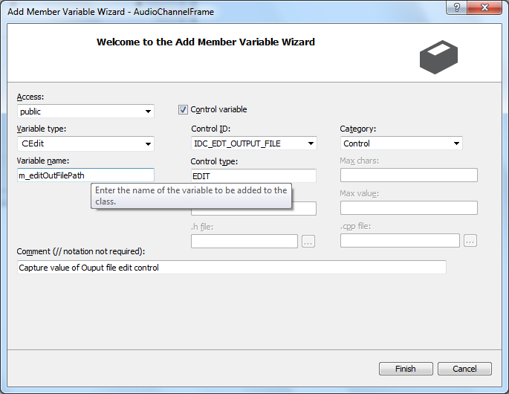
Please perform similarly to bind variable “m_editLogResult” for item “Text box for result log”.

Task 2 – Configure the project to use library Libsndfile

This exercise helps you to configure the project AudioChannelFrame using the library Libsndfile which is installed in above task 1.

  - Going to Property Page of the project by right-click on the project in Solution Explorer panel.

  - Add folder “include” of the library Libsndfile into the project.
Select item “Configuration Properties > VC++ Directories” in left panel.
From right panel, click on down arrow icon of item “Include Directories”, click on “<Edit...>”.

Input “include” folder of the libsndfile “C:\Program Files (x86)\Mega-Nerd\libsndfile\include”.
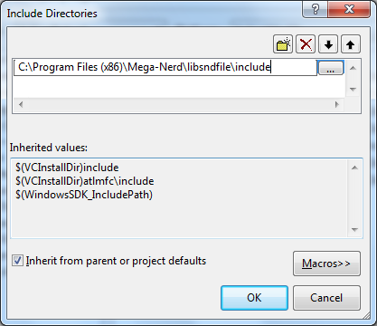
  - Add folder “lib” of the library Libsndfile into the project.
Similar the above step 2, from right panel, add folder “C:\Program Files (x86)\Mega-Nerd\libsndfile\lib” into item “Lib Directories”

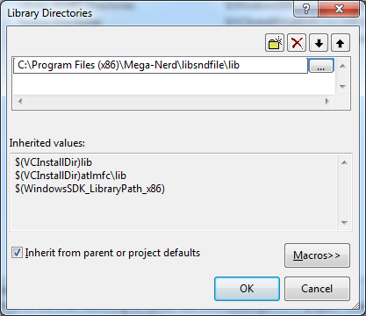
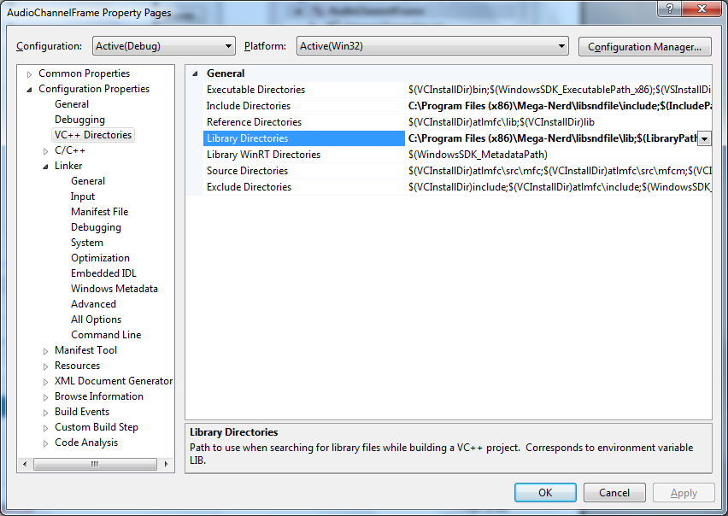

  - Add name of library “libsndfile-1.lib”
Similar the above step 2, from left panel, select item “Configuration Properties > Linker > Input”.
From the right panel, input “libsndfile-1.lib” into item “Additional Dependencies”.
Add folder “C:\Program Files (x86)\Mega-Nerd\libsndfile\lib” into item “Lib Directories”.
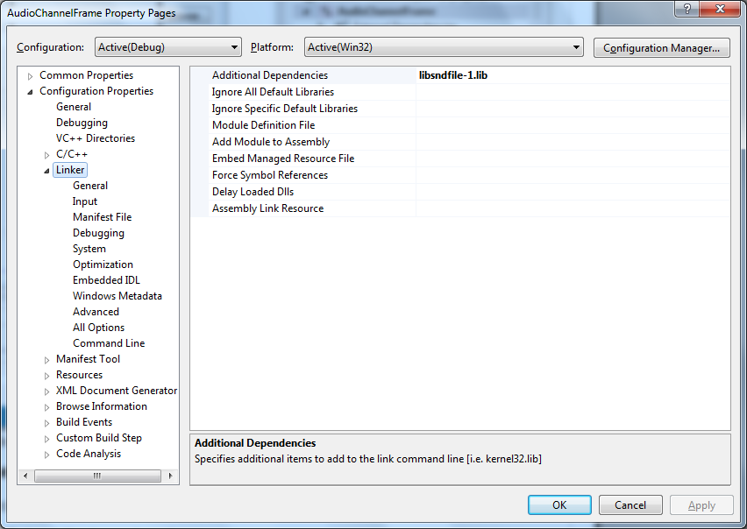

Exercise 3 – Write code to read audio file and output to text file

This exercise helps you call procedures/functions from library Libsndfile to read WAV file and out put to a text file. The original source code is at “https://github.com/erikd/libsndfile/blob/master/examples/sndfile-to-text.c”.

Task 1 – Generate source to process event of buttons
  - Generate source code to process event “Click on button Browse” by double-click on button “Browse”
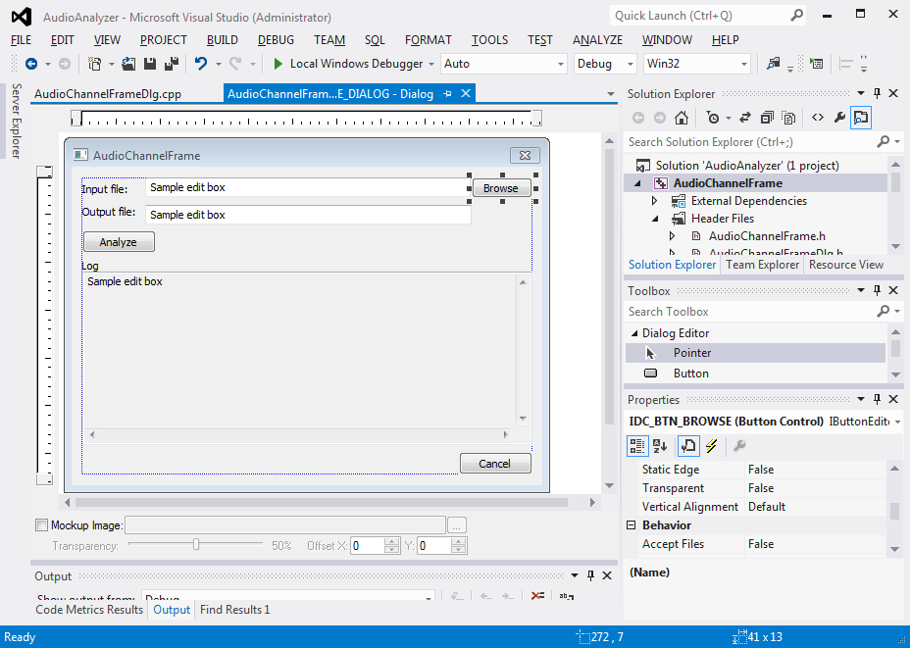
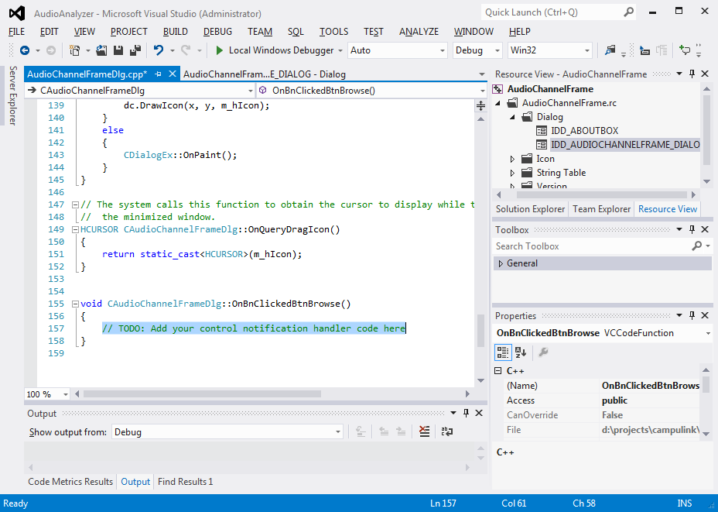
Update code for method “OnBnClickedBtnBrowse” as below:
void CAudioChannelFrameDlg::OnBnClickedBtnBrowse()
{
CFileDialog *dlg = new CFileDialog(
TRUE,
NULL,
NULL,
OFN_FILEMUSTEXIST | OFN_OVERWRITEPROMPT | OFN_PATHMUSTEXIST,
_T("All files|*.*|"),
AfxGetMainWnd());

if (dlg->DoModal() == IDOK)
{
m_editInFilePath.SetWindowText(dlg->GetPathName());
}
else
{
// Do nothing
}

delete dlg;
dlg = NULL;
}

  - Generate source code to process event “Click on button Analyze”.
Similar the above step 1, double-click on button “Analyze”. Then write some codes to display the status of processing:

void CAudioChannelFrameDlg::OnBnClickedBtnAnalyze()
{
// Content value of Input file path
CString strInFilePath;

// Get value of Input file path
m_editInFilePath.GetWindowText(strInFilePath);

m_editLogResult.SetWindowTextW(_T("Reading file ") + strInFilePath + "...");
}
Now, you can compile and run the application to check activities of button “Browse”, “Analyze”.

Task 2 – Call the library Libsndfile
To read the audio file and output to text file, we study and re-use the source code at “https://github.com/erikd/libsndfile/blob/master/examples/sndfile-to-text.c”.
This task will develop a class AudioFileAnalyzer to handle this processing.

  - Add new class by right-click on the project from panel Solution Explorer, select menu “Add > Class...”

Select item “C++ Class”. Then click on button “Add”.
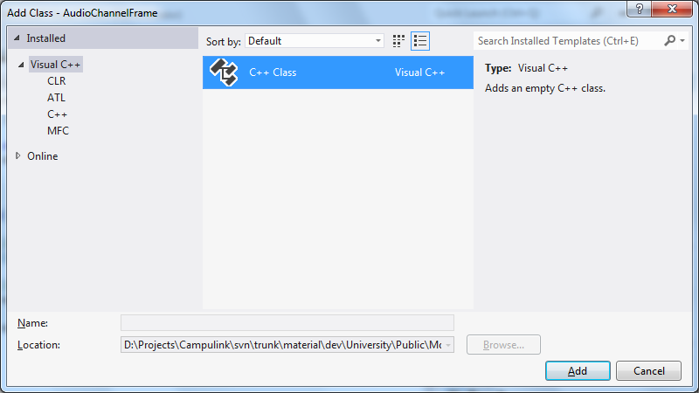

Input for Class name: AudioFileAnalyzer
Then, click on button “Finish”
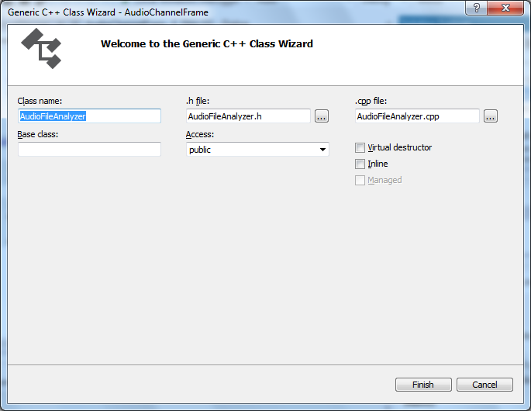
Generated source code of AudioFileAnalyzer.h is as below:

#pragma once
class AudioFileAnalyzer
{
public:
AudioFileAnalyzer(void);
~AudioFileAnalyzer(void);
};

Generated source code of AudioFileAnalyzer.cpp is as below:

#include "stdafx.h"
#include "AudioFileAnalyzer.h"

AudioFileAnalyzer::AudioFileAnalyzer(void)
{
}

AudioFileAnalyzer::~AudioFileAnalyzer(void)
{
}

  - Write code for header file AudioFileAnalyzer.h

Update source code of AudioFileAnalyzer.h is as below:

#pragma once
#include <stdio.h>
#include <stdlib.h>
#include <string>

#include <sndfile.h>

using namespace std;

#define BLOCK_SIZE 512

class AudioFileAnalyzer
{
private:
CString m_inFilePath;
CString m_outFilePath;

public:
AudioFileAnalyzer(CString inFilePath, CString outFilePath);

void ConvertToText(SNDFILE *inFile, FILE *outFile, int channels);
CString ProcessFile();

~AudioFileAnalyzer(void);
};

Highlighted lines are added or updated.
Default constructor AudioFileAnalyzer() is deleted.

  - Write code for file AudioFileAnalyzer.cpp

Update source code of AudioFileAnalyzer.cpp is as below:

#include "stdafx.h"
#include "AudioFileAnalyzer.h"

AudioFileAnalyzer::AudioFileAnalyzer(CString inFilePath, CString outFilePath)
{
m_inFilePath = inFilePath;
m_outFilePath = outFilePath;
}

void AudioFileAnalyzer::ConvertToText(SNDFILE *inFile, FILE *outFile, int channels)
{
float *buf = new float[channels * BLOCK_SIZE];
int k, m, readCount ;

while ((readCount = sf_readf_float(inFile, buf, BLOCK_SIZE)) > 0)
{
for (k = 0; k < readCount; k++)
{
for (m = 0; m < channels; m++)
{
fprintf(outFile, " % 12.10f", buf [k * channels + m]) ;
}
fprintf(outFile, "\n") ;
}
}

delete[] buf;
} /* convert_to_text */

CString AudioFileAnalyzer::ProcessFile()
{
CString strResult;
SNDFILE *inFile = NULL;
FILE *outFile = NULL;
SF_INFO sfinfo;

string inFilePath = CW2A(m_inFilePath);

inFile = sf_open(inFilePath.c_str(), SFM_READ, &sfinfo);

if (inFile == NULL)
{
// Error
strResult = "[Error]";
}
else
{
string outFilePath = CW2A(m_outFilePath);
/* Open the output file. */
fopen_s(&outFile, outFilePath.c_str(), "w");

if (outFile == NULL)
{
strResult = "Not able to open output file";
}
else
{
ConvertToText(inFile, outFile, sfinfo.channels);
strResult = "View result in output file";
}
}

// Close files
sf_close(inFile);
fclose(outFile);

return strResult;
}

AudioFileAnalyzer::~AudioFileAnalyzer(void)
{
}

Now you can compile the source code by press hot key Ctrl+Shift + B. But could not run the project because below error.

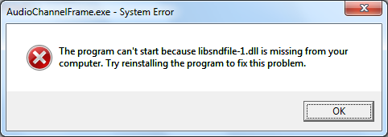
Go to next stop to solve this problem.

  - Run the solution with default mode “Debug”
Copy file “C:\Program Files (x86)\Mega-Nerd\libsndfile\bin\libsndfile-1.dll” into the folder “Debug” of you r solution. Ex: D:\Projects\YourSound\Training\AudioAnalyzer\Debug.
Now you can compile and run the project by press hot key “F5”.

However, class AudioFileAnalyzer has not used to process the audio file yet.

  - Upgrade source code to process event “Click on button Analyze”.
Old
void CAudioChannelFrameDlg::OnBnClickedBtnAnalyze()
{
// Content value of Input file path
CString strInFilePath;

// Get value of Input file path
m_editInFilePath.GetWindowText(strInFilePath);

m_editLogResult.SetWindowTextW(_T("Reading file ") + strInFilePath + "...");
}
New (source file AudioChannelFrameDlg.cpp)

…
#include "AudioFileAnalyzer.h"
…

void CAudioChannelFrameDlg::OnBnClickedBtnAnalyze()
{
// Content value of Input file path
CString strInFilePath;

// Content value of Output file path
CString strOutFilePath;

// Get value of Input file path
m_editInFilePath.GetWindowText(strInFilePath);

m_editLogResult.SetWindowTextW(_T("Reading file ") + strInFilePath + "...");

// Get value of Ouput file path
m_editOutFilePath.GetWindowTextW(strOutFilePath);

// Initializing the AudioFile Analyser and processing
AudioFileAnalyzer afAnalyzer = AudioFileAnalyzer(strInFilePath, strOutFilePath);
CString strResult = afAnalyzer.ProcessFile();

// Add result log
CString strResultLog;
m_editLogResult.GetWindowTextW(strResultLog);
m_editLogResult.SetWindowTextW(strResultLog + "\r\n" + strResult);
}

Now you can compile and run the project by press hot key “F5”.
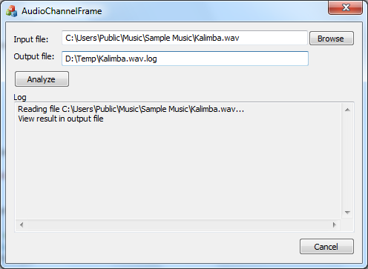
Note:
To convert audio file mp3 into wav, Audacity (http://audacity.sourceforge.net) is a good reference tool.
It's simple to use: Open file mp3, then export to wav by going menu “File > Export Audio...”

Exercise 4 – Analysis code

This exercise helps you using feature “Code Analysis” in Visual Studio 2012.

Task 1 – Run Code Analysis on solution
  - Run Code Analysis on Solution by press hot key Alt+F11

  - Run Code Analysis on Solution by press hot key Alt+F11

For this solution, there is an issue at line 66 of file AudioFileAnalyzer. The line number can be different in your solution.

Solution: Check to make sure the variable “outFile” is not NULL before call statement “fclose(outFile)”.
Fixed source code:
// Close files
sf_close(inFile);

if (outFile != NULL)
{
fclose(outFile);
}
else
{
// Do nothing
}

For statement “sf_close(inFile);”, although the Visual Studio Code Analysis does not report any issue but it should be check NULL before close it.

